NAME: NAVODITAA A.R.
ROLL NO.:241901071

Exercise 2

TCP CLIENT – SERVER USING SOCKET PROGRAMMING IN PYTHON

AIM:
To implement TCP client–server communication using socket programming in Python.

ALGORITHM:
SERVER:

1. Create a socket using socket.socket().
2. Bind the socket to an IP and port using bind ().
3. Listen for client connections using listen ().
4. Accept client connection using accept ().
5. Receive data using recv ().
6. Send response using send ().
7. Close connection.

CLIENT:

1. Create a socket using socket.socket().
2. Connect to the server using connect ().
3. Send data using send ().
4. Receive response using recv ().
5. Close connection.

CODE:
SERVER:
import socket
sockfd=socket.socket(socket.AF_INET, socket.SOCK_STREAM)
print(‘Socket Created’)
sockfd.bind((‘localhost’,55555))
sockfd.listen(3)
print(“Waiting for connections”)
while True:
clientfd,addr=sockfd.accept()
receivedMsg=clientfd.recv(1024).decode()
print(”Connected with “,addr)
print(“Message Received from Client: “,receivedMsg)
clientfd.send(bytes(receivedMsg,’utf-8’))
print(“Message reply sent to Client!”)
print(“Do you want to continue(type y or n):”)
choice=input()
if choice==’n’:
break
CLIENT:
import socket
clientfd=socket.socket(socket.AF_INET, socket.SOCK_STREAM)
clientfd.connect((‘localhost’,55555))
name=input(“Enter your message:”)
clientfd.send(bytes(name,’utf-8’))
print(”Message Received from Server: “,clientfd.recv(1024).decode())

OUTPUT:

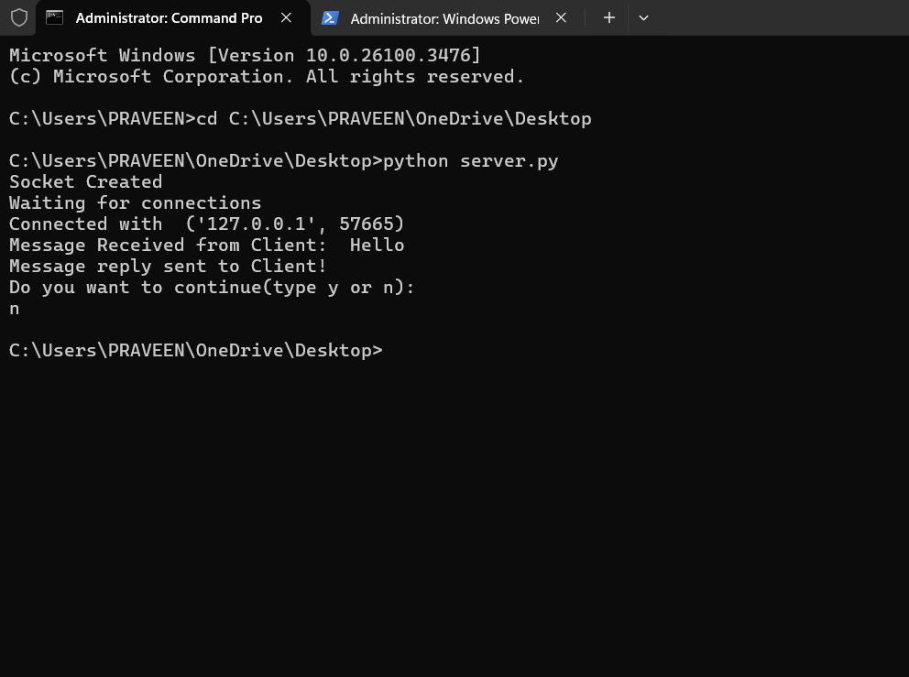
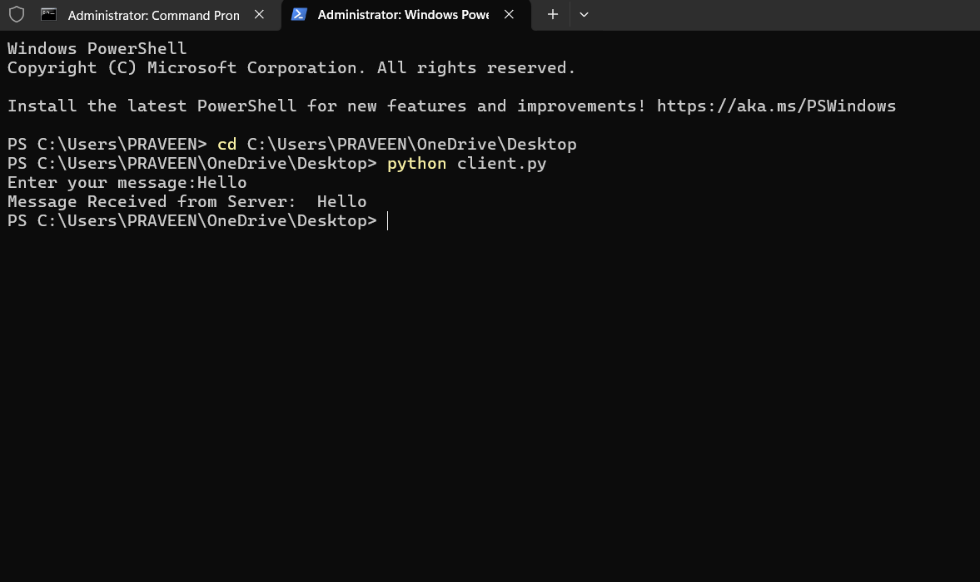

RESULT:
Thus, TCP client-server communication was successfully implemented using Python.

